## **INFSCI 0017 – Fundamentals of Object-Oriented Programming (Fall 2018)**

## **Lab 11**

## Topics Reviewed

1. Java SWING
2. Graphical User Interface (GUI) in Java

## Grading and Submission

You are to write a complete Java program that meets the requirements outlined in the Lab 11 Tasks section.

Once you have completed the program, you should demonstrate your program for your Lab TA.

There will be a total of 5 points for this lab

Note that if your program does not compile, the TA will not grade it.

## Lab 11 Tasks

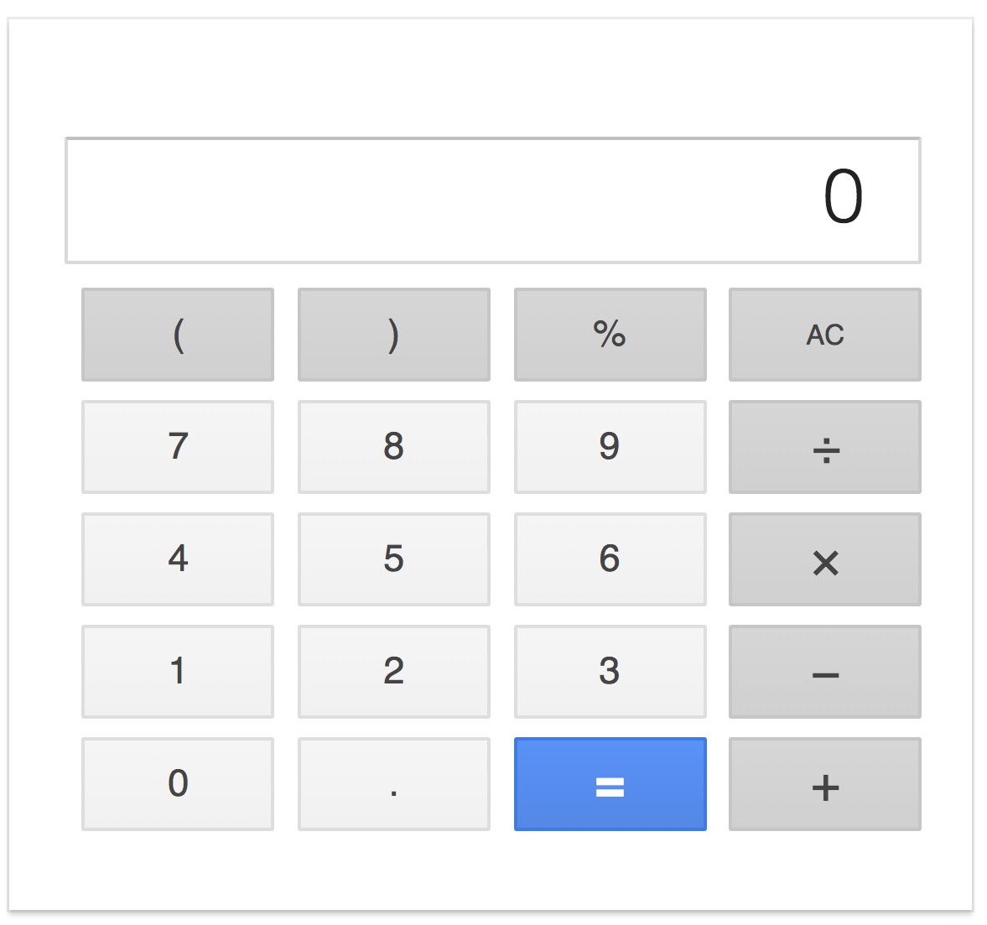

* Using Java SWING, create a graphical user interface for a calculator similar to the one shown above.
* Use absolute layout
* Create all buttons and the text field by declaring and instantiating appropriate SWING objects - you are NOT allowed to use WindowBuilder or any other GUI design tool for this lab assignment.
* Add event handlers to all number buttons - clicking a number button should place an appropriate number into the text field